Ref : <https://sensing.honeywell.com/honeywell-sensing-asdx-series-analog-pressure-sensors-product-sheet-008090-12-en.pdf>

A sensor is a device that detects events or changes in its environment and sends the information to other electronics.

Arduino sensors

Honeywell ASDX Series Silicon Pressure Sensor

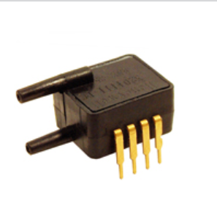

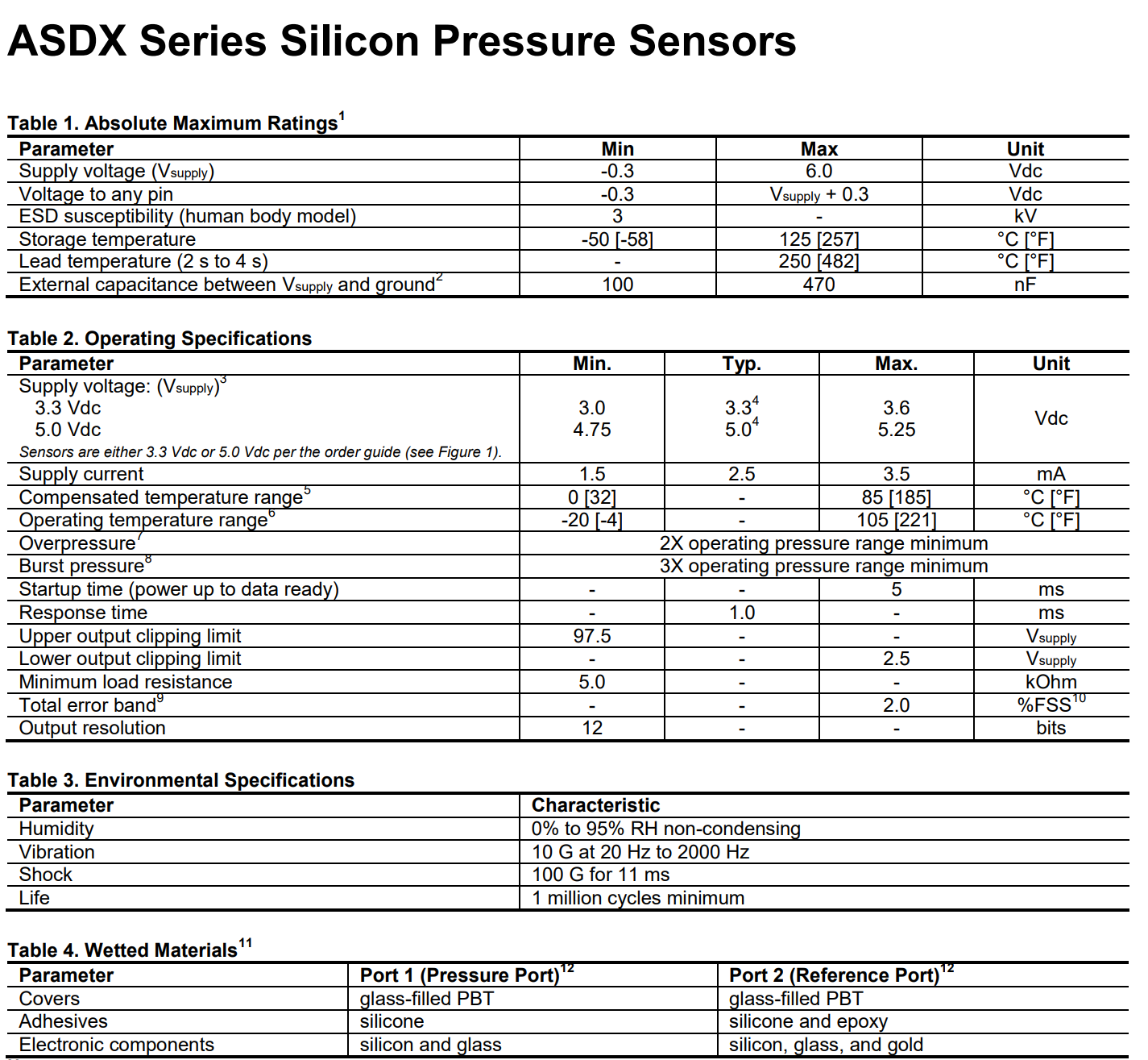

The ASDX silicon pressure sensor offers a ratiometric analog interface for reading pressure over specified full scale pressure span.

Ref <http://microcontrollerslab.com/heart-beat-sensor-arduino/>

Heartbeat Monitor

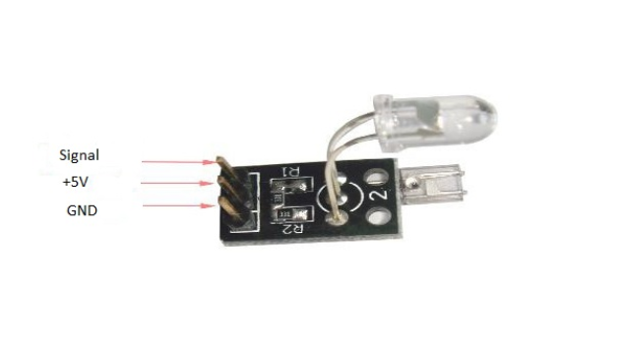

The heart beat sensor uses infrared led (IR) and a phototransistor to detect the pulse of a finger and whenever a pulse is detected the red led flashes.

Oxygen Sensor

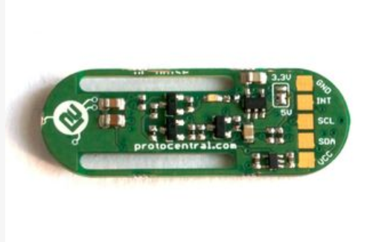

Ref <http://www.instructables.com/id/Finger-Pulse-Oximeter-Using-MAX30100/>

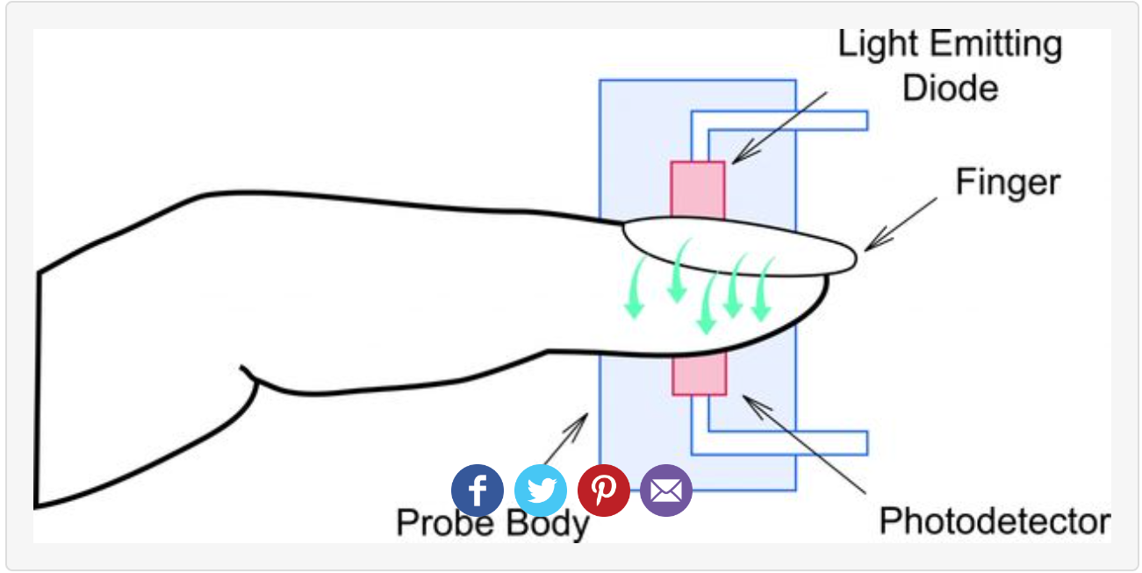

Pulse oximetry operates on the red and IR light absorption characteristics of oxygenated and deoxygenated hemoglobin. Concentration can be calculated from the ratio between the absorption of red light and IR light by the hemoglobin.

Mobile Sensors

ref <http://storm.cis.fordham.edu/~gweiss/presentations.html>

Types of Sensors

* Location
* Proximity and Motion
* Tri-Axial Accelerometer
* Gyroscope
* Temperature and Humidity
* Heart rate (not common)

Location

* GPS
  + Accurate to 10ft
* Cell tower triangulation
  + Less power compared to GPS - not as accurate
  + Can improve speed of GPS loss and wi-fi can improve the accuracy of GPS
* Proximity and Motion
  + Measured in centimeters
* Tri-Axial Accelerometer
  + Common in most smart smartphones and watches
  + Gravity included
  + On Android and IOS default range is +2g to -2g
    - Bigger range means lower resolution
    - Axes are fixed to phone and hence changes as phones shifts
  + Sample rates 20-50hz
* Gyroscope
  + Determine position and orientation of device
  + Measures rotation in radians seconds about axis
  + Sensitivity to rotation is more robust to motion
* Temperature and Humidity
  + Track whether and building condition

Image grove sensor <http://www.trossenrobotics.com/p/grove-3-axis-accelerometer-sensor.aspx>

Heartbeat

<https://circuitdigest.com/microcontroller-projects/heartbeat-monitor-project-using-arduino>

Finger Pulse Oximeter Using MAX30100

<http://www.instructables.com/id/Finger-Pulse-Oximeter-Using-MAX30100/>